“Where do I put my data?”

Finding an appropriate long-term data repository/database

Researchers should ideally determine if an appropriate domain repository exists for their data, and tools such as FAIRsharing.org and re3data.org can help with this determination. Alternatively there are multiple “generalist” repositories available with broader focus, including Ag Data Commons. Researchers need to consider the requirements of their community, funder, institution, publisher, and possibly other factors to select an appropriate repository.

re3data.org
re3data is a global registry of research data repositories that covers research data repositories from different academic disciplines. It includes repositories that enable permanent storage of and access to data sets to researchers, funding bodies, publishers, and scholarly institutions. re3data.org promotes a culture of sharing, increased access and better visibility of research data.
Search
The home page displays a simple search box to enter term(s) of interest, e.g. genomics, animal health, soil, crops; the search form is also accessed via the Search button at the top, and remains above the results to allow further refinement of the query.
Browse
You can browse among the collection of repositories by Subject, Content Type, or Country, via the Browse button at the top.
Filter
Search results can be filtered (narrowed down) by a number of facets displayed to the left of the results. Each facet can be expanded by clicking the + sign to drill down to more specific criteria, with the number of results for each shown in parentheses. For example a search for ‘soils’ returns 19 results that can then be narrowed down by subject, content type, license, etc.
Sample Record
A typical data repository record in re3data has tabs displaying
- general descriptive information: subjects, description, contacts, keywords, etc.
- institution responsible for the resource: organization name, URL, contact, etc.
- terms of use: policies, data access, licenses, etc.
- standards : repository software, data citation guidelines, alerting services, etc.
A sample citation is also provided showing how to cite the re3data record.
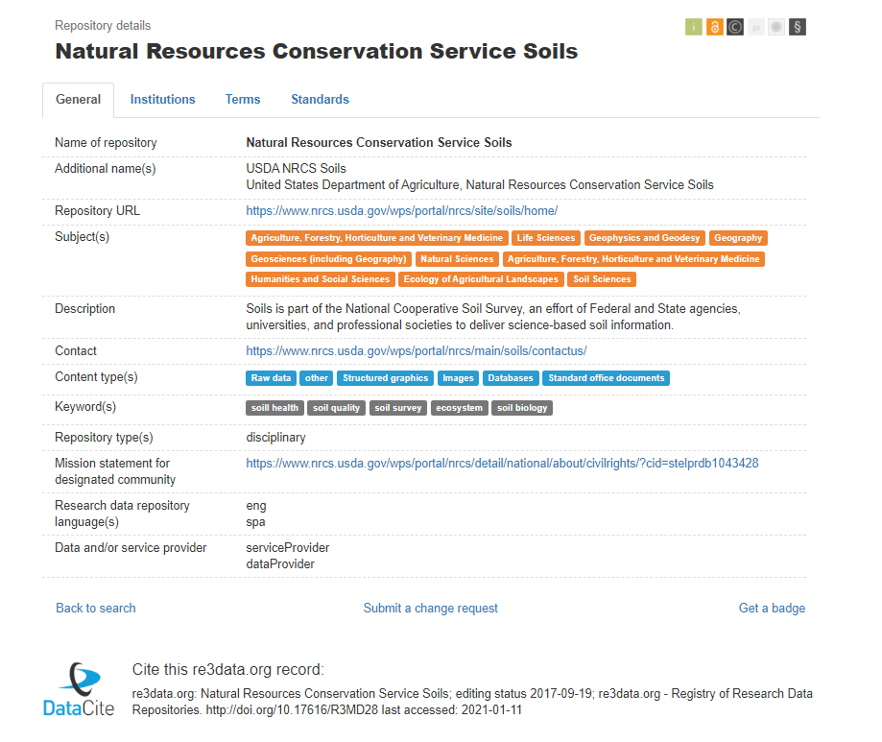

FAIRsharing.org
FAIRsharing.org is a curated, informative and educational resource on worldwide data and metadata standards, inter-related to databases and data policies. Researchers can use FAIRsharing as a lookup resource to identify and cite the standards, databases or repositories that exist for their data and discipline, for example, when creating a data management plan for a grant proposal or funded project; or when submitting a manuscript to a journal, to identify the recommended databases and repositories, as well as the standards they implement to ensure all relevant information about the data is collected at the source.
Search
Selecting the Databases button in the header returns a simple search form to enter term(s) of interest. The search form can be expanded to display an Advanced option for combining multiple fields into the query, e.g. Domain Ontology, Species, Subject Ontology, Tags, and Organization(s). The search box remains at the top of the results to allow further refinement of the query.
Browse
The Databases button also returns a full list of records that can be sorted by Name, Taxonomy, or Domain, as well as using the filters to narrow the results.
Filter
Facets at left allow the results to be narrowed down by Domain (e.g. Sequence, Gene Expression Data, Annotation), Subject (e.g. Agriculture, Biodiversity, Virology), Taxonomy, Country, or Organization.
Sample Record
A typical data repository record in FAIRsharing provides
- general information: subjects, description, homepage, date created, etc.
- taxonomic range: Latin names of organisms, families, etc.
- knowledge domains
- subjects
- related standards: terminology/ontologies/taxonomies, models, formats, schemas, etc.
- tools: applications supporting or associated with the data
- related databases
- credit: maintainer, funding, grants, etc.
- publications: citations using or describing the data
- policies: pertaining to use or implementation
A sample citation is also provided showing how to cite the FAIRsharing record and key publication.

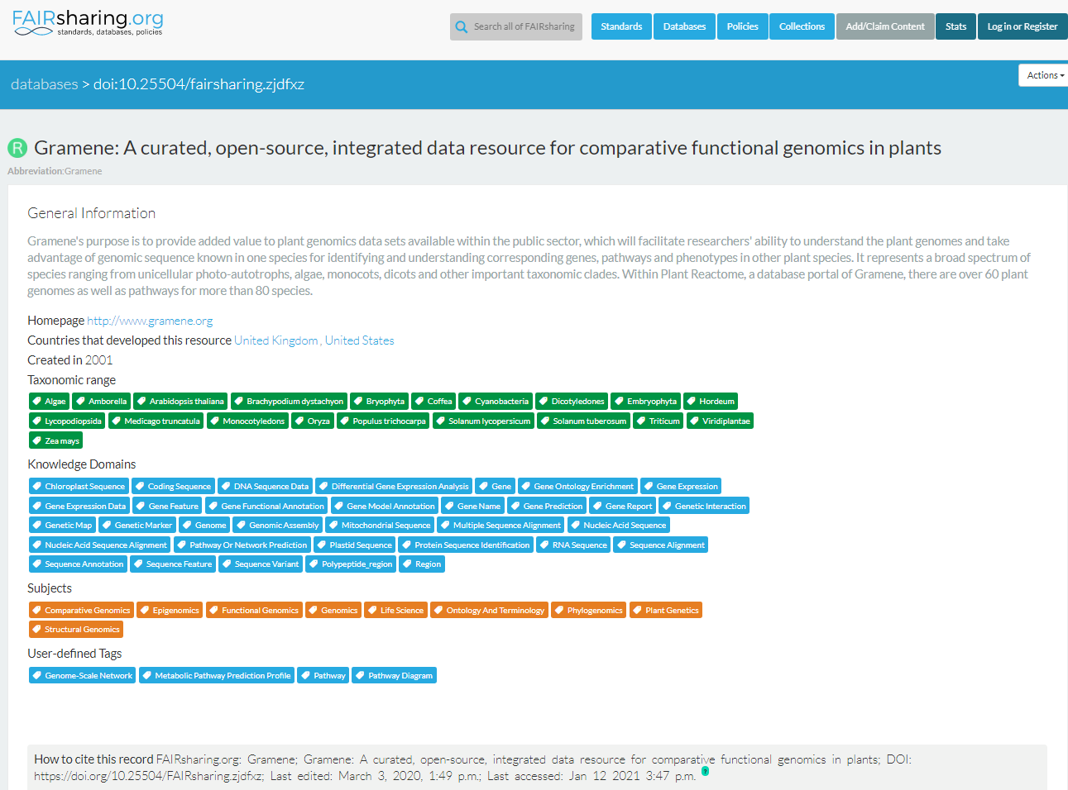
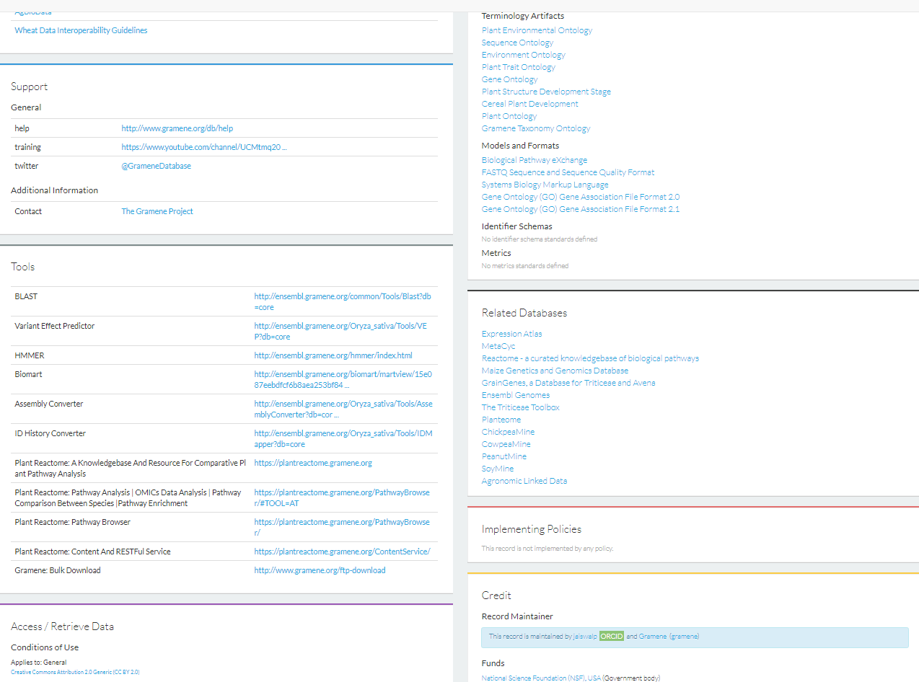

Other resources

Journal publisher recommendations
Some lists of recommended research data repositories from major academic publishers:
- Springer Nature/BioMed Central: https://www.springernature.com/gp/authors/research-data-policy/repositories/12327124
- Nature Scientific Data: https://www.nature.com/sdata/policies/repositories
- Elsevier: https://www.elsevier.com/authors/author-resources/research-data/data-base-linking#repositories
- DataONE member repositories: https://www.dataone.org/network/
- PLoS ONE: https://journals.plos.org/plosone/s/recommended-repositories
Repository Finder
Repository Finder, a pilot project of the Enabling FAIR Data Project led by the American Geophysical Union (AGU) in partnership with DataCite and the Earth, space and environment sciences community, can help you find an appropriate repository to deposit your research data. The tool is hosted by DataCite and queries the re3data registry of research data repositories.
DataSeer
Designed primarily for journal publisher and funder use cases, DataSeer uses Natural Language Processing (NLP) on an uploaded manuscript to a suggest which datasets from the article should be shared, what format they should be in, and which repository is most suitable.

OpenDOAR

OpenDOAR is the quality-assured, global Directory of Open Access Repositories that provide free, open access to academic outputs and resources. Each repository record within OpenDOAR is curated by an editorial team to offer a trusted service for the community. Criteria for listing include open access worldwide without fees, registration or logins. A variety of academic content types are included, e.g. journal articles, theses/ dissertations, reports, working papers, conference proceedings, books/ book chapter) and/or academic resources with sufficient metadata or documentation to make the material re-usable (e.g. archival material, datasets, software, images, videos, learning material).

NAL selected list of domain-specific repositories [in progress]

Note this does not refer to data/metadata standards supported by the repository.

